**Scenario: You have submitted a paper to a conference and you have gotten the comments. You need to know the comments about “communication” in your paper, and you want to see what part of paper was mostly.**

**We have made a system that extracts information of articles and allows analysis based on them. We want to compare directly checking the paper reviews and the output of analysis of the extracted information.**

Please do these two tasks then answer the questionnaire.

**TASK** 1.

1. **checkout comments performed by Reviewer2 about “communication” and say that comment was too general?**

1. Using this link <https://afshin.databox.me/public/Article1.html#2987879860>
2. Using the an automatic system that searches the word comment between comments and shows the response shown below this image

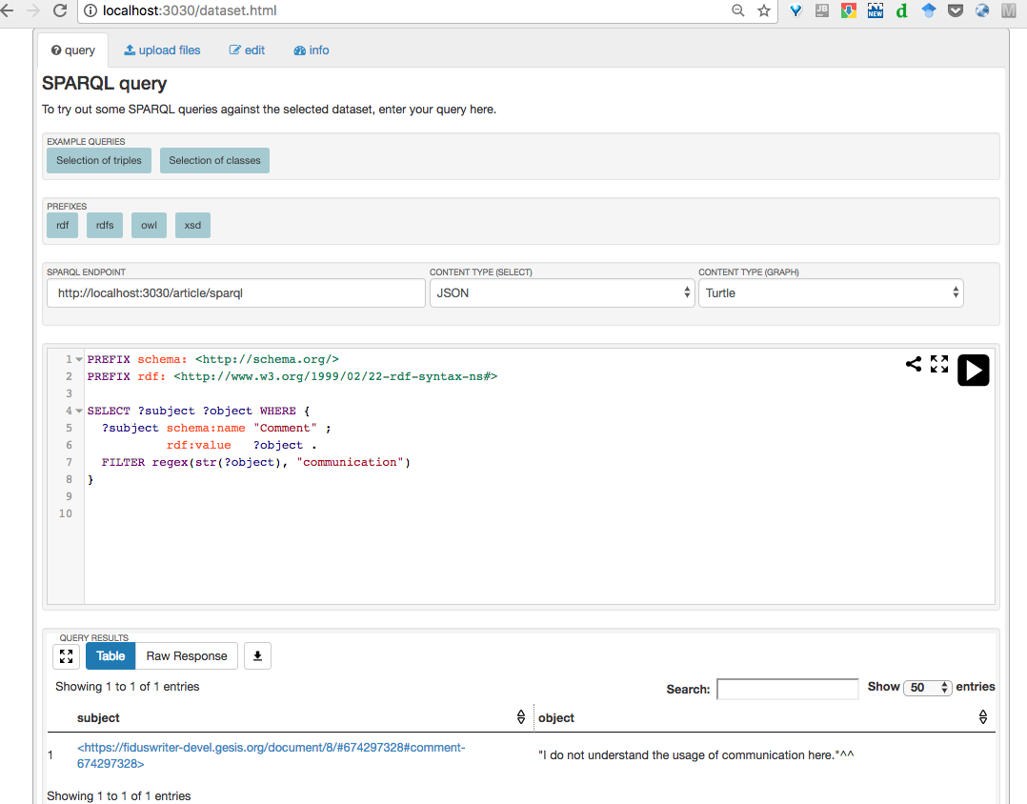

**TASK** 2.

**2. Find out the most commented section in the article.**

1. Using this link <https://afshin.databox.me/public/Article1.html#2987879860>
2. Using the result of the analysis shown below this image

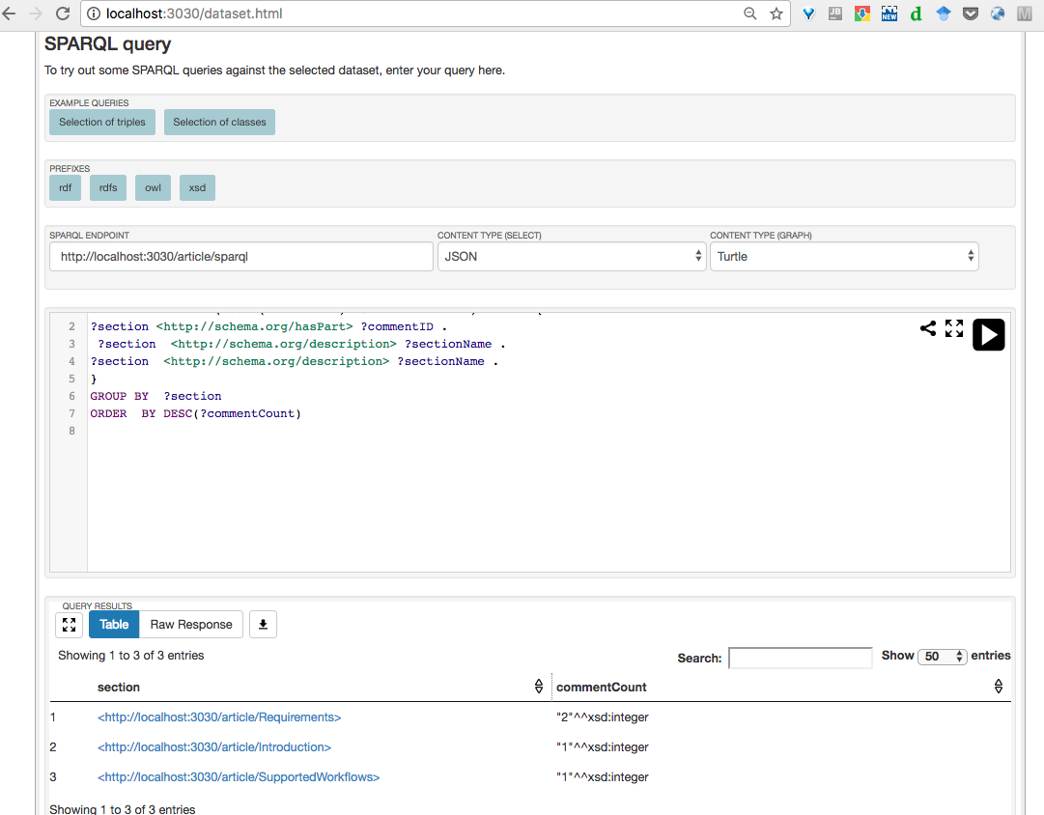

**Overall reaction to the system**

1. Between 1. **terrible** to 9. **Wonderful** what point do you give. 8
2. Between 1. **difficult** to 9. **easy** what point do you give. 9
3. Between 1. **frustrating** to 9. **satisfying** what point do you give. 9
4. Between 1. **Inadequate** **power** to 9. **adequate** **power** what point do you give. 9
5. Between 1. **dull** to 9. **stimulating** what point do you give. 8
6. Between 1. **rigid** to 9. **flexible** what point do you give. 9

**Learning**

1.Have you ever reviewed a paper? yes

2. Learning required to do the task? No, I work with RDF data and triple stores every day

3. Remembering the names and use of commands?no it did not need

4.Performing tasks is straightforward? Yes

5.Supplemental reference materials? Did not required for me

**System Capabilities**

6.System speed? Is very faster to use the queries

7.System reliability? It never mistakes on tasks like counting specially on long papers it can happen for users without the system

8.System tends to be? very helpful

9.Correcting your mistakes? yes

10. Designed for all levels of users? I think yes

List of the most Negative aspects?

1. Longer papers could be use to show the difference in time and helpfulness

2.

3.

List of the most Positive aspects?

1. Faster, specially it helps for long papers
2. In the first sight it gives to user what the reviewed mean

3.